P.Sivakiran
23MIS0674

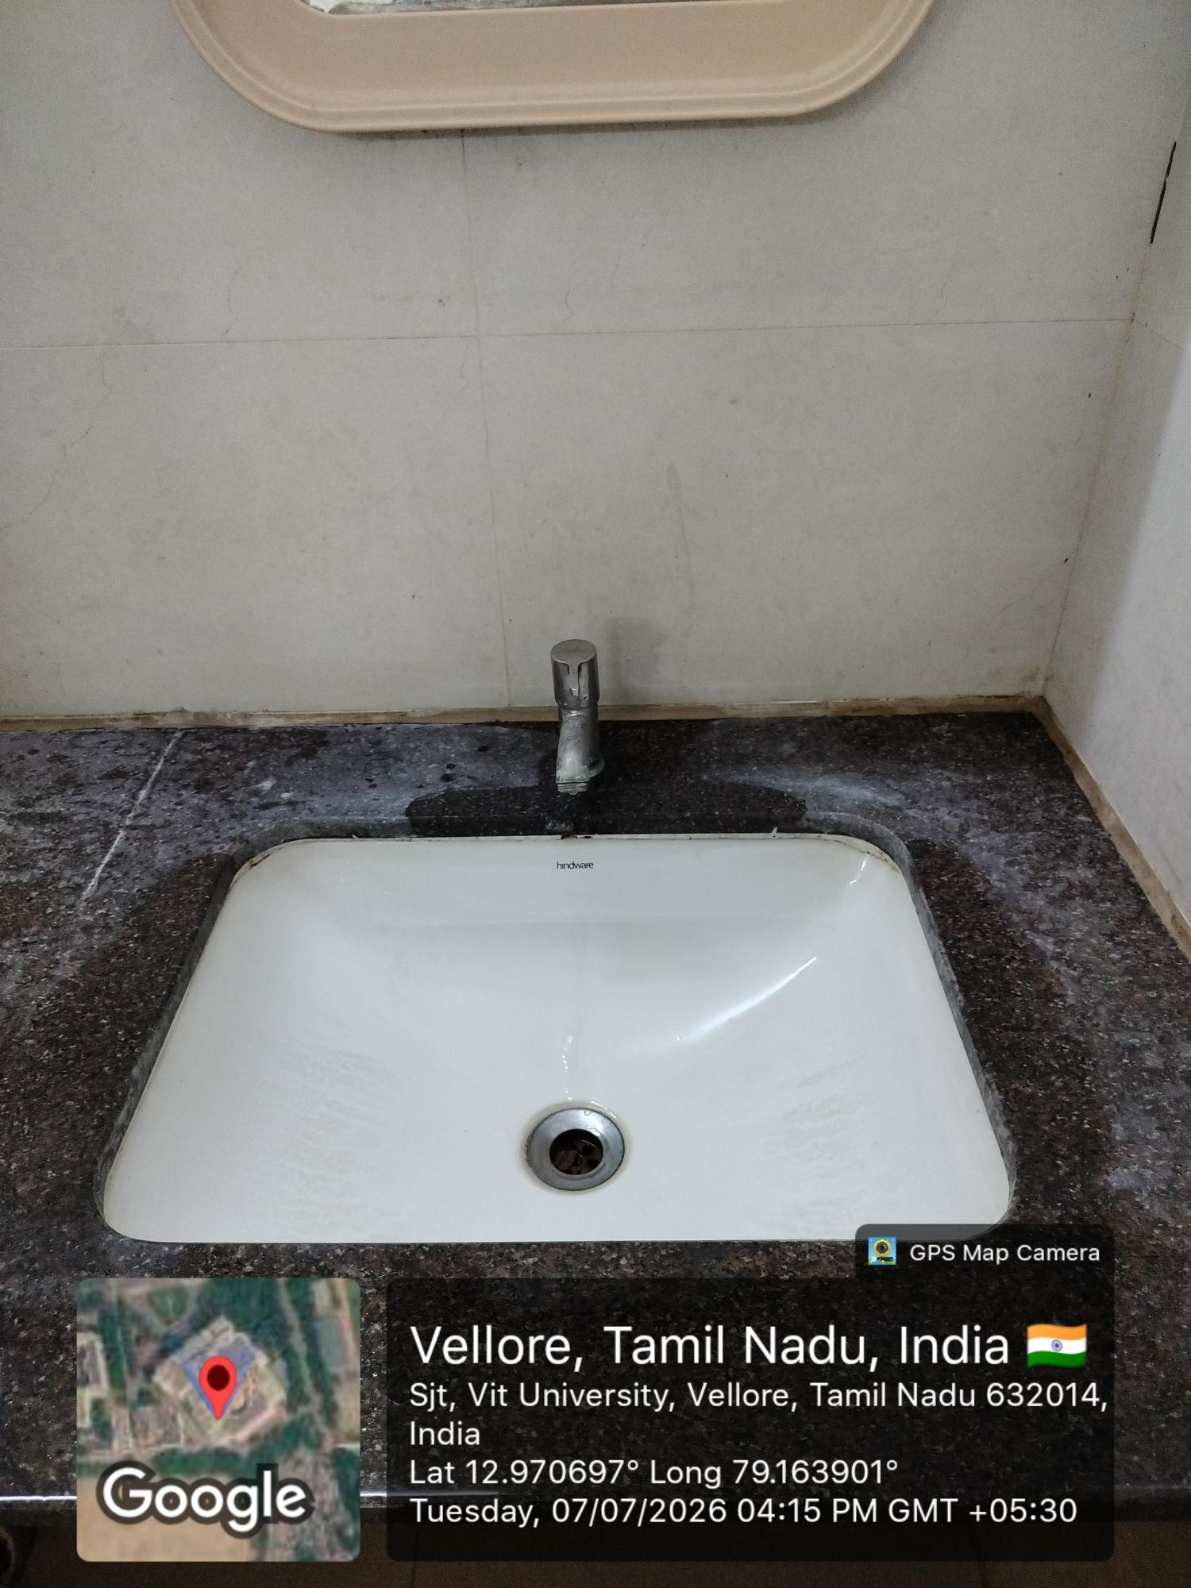

Bad Design 1: Wash Basin with Very Small Faucet
Source of Photograph: Captured by me (Own Photograph)
Place: VIT University, Vellore – Washroom
Description: The wash basin has a very short faucet positioned close to the sink. This makes it difficult for users to wash their hands comfortably, causing water to splash around the basin.
Reasons why the design is bad:
Faucet is too short, reducing hand movement space.
Water splashes onto the countertop.
Difficult to wash larger objects such as bottles.
Uncomfortable for users with large hands.
Leads to water wastage and an untidy wash area.
Suggested Improvements:
Install a longer faucet with better reach.
Increase the distance between the faucet and basin edge.
Use a splash-resistant basin design.
Improve drainage to avoid water accumulation.
Conduct ergonomic testing before installation.

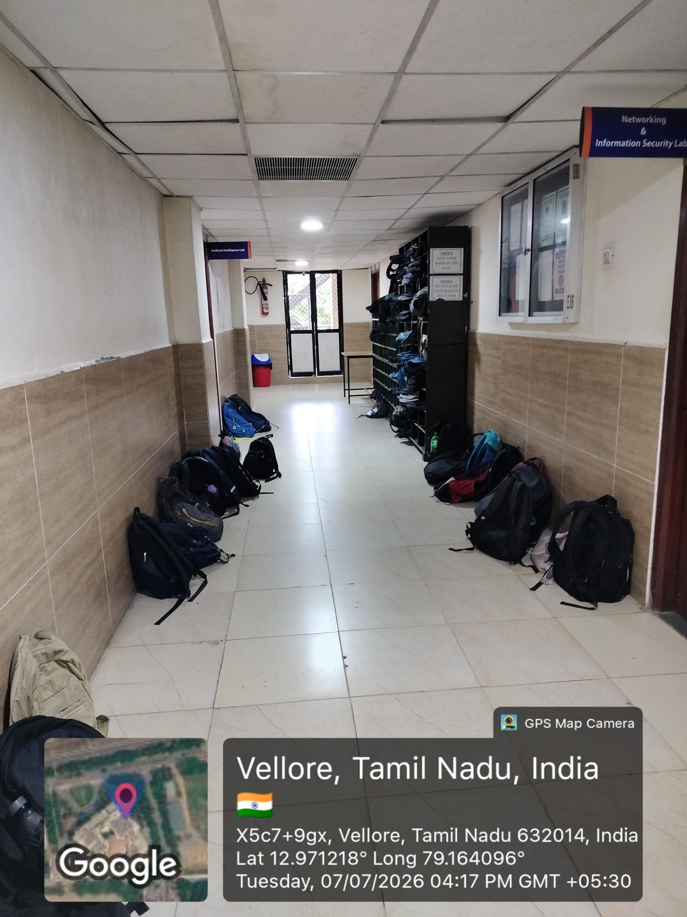
Bad Design 2: Bags Placed in the Corridor
Source of Photograph: Captured by me (Own Photograph)
Place: VIT University, Vellore – Academic Block Corridor
Description: Students keep their bags along both sides of the corridor, reducing walking space and creating an obstacle for movement.
Reasons why the design is bad:
Blocks the walking pathway.
Increases the risk of tripping.
Difficult during emergencies or evacuations.
Makes the corridor look cluttered.
No dedicated storage space for bags.
Suggested Improvements:
Provide designated bag racks or lockers.
Mark a specific area for keeping bags.
Keep emergency pathways completely clear.
Display signs reminding students not to block walkways.
Increase storage facilities near classrooms.

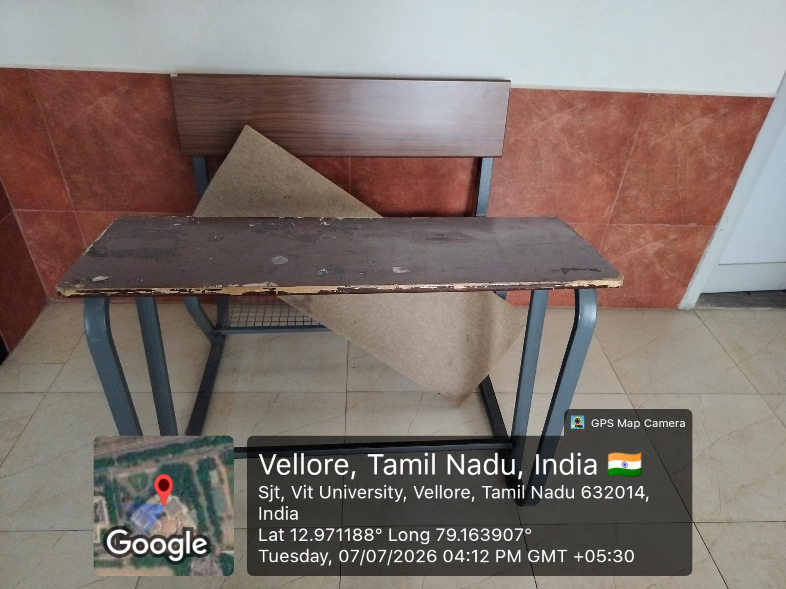

Bad Design 3: Damaged Classroom Desk
Source of Photograph: Captured by me (Own Photograph)
Place: VIT University, Vellore – Classroom
Description: The classroom desk has a damaged and uneven writing surface with chipped edges, making it uncomfortable and unsafe for students.
Reasons why the design is bad:
Uneven surface makes writing difficult.
Chipped edges may cause injuries.
Poor appearance reduces classroom quality.
Difficult to clean and maintain.
Can become unstable over time.
Suggested Improvements:
Replace the damaged tabletop.
Smooth and round off sharp edges.
Use durable, scratch-resistant materials.
Conduct regular maintenance inspections.
Repair or replace damaged furniture promptly.

